EXHIBIT XVI

COMPUTATIONAL TOOLS AND INTEGRATED MANAGEMENT SYSTEM

FPSO PETROBRAS 91 (P-91)

************Revision Control*************
Rev 0: Bid original version

SUMMARY

1. OBJECTIVE 3
2. REFERENCE DOCUMENT 3
3. DEFINITIONS 3
4. INTRODUCTION 3
5. SOFTWARE TOOLS GENERAL VIEW 4
6. SCHEDULE 6
7. ENGINEERING 7
8. CONTROL AND MANAGEMENT TOOLS 7
9. BUYER SYSTEMS 8
10. DELIVERABLES 9
11. APPENDICES 10

- OBJECTIVE
This document aims to establish guidelines, responsibilities, and requirements to be adopted by SELLER in order to use computational tools and integrated management system.

- REFERENCE DOCUMENT
- I-ET-3000.00-1350-940-P4X-014 Technical Requirements for Digital Engineering for BOT
- EXHIBIT III – Directives for Product Development
- EXHIBIT IV – Directives for Product Fabrication
- EXHIBIT V – Directives for Acquisitions
- EXHIBIT VI – Directives for Planning and Control
- EXHIBIT VII – Directives for Quality Assurance System
- EXHIBIT VIII – Directives for Commissioning Process

- DEFINITIONS
For the purposes of this document, the definitions contained on the Agreement and its Exhibits apply along with the following:
CAE (Computer Aided Engineering): Represented by “smart software design tools” with their databases and appropriated usage in order to reproduce the same information among different documents and, therefore, reduce inconsistencies in a Project.
2D: Generic classifications of elements, drawings, or forms of a two-dimensional or textual nature (Data sheets, flow diagrams, etc.).
3D: Three-dimensional representation of elements.
EDM (Electronic Document Management): Tool for management technical and administrative documents between the SELLER and BUYER.
RO (Occurrence Report): Report intended for recording of progress and occurrences related to the contract execution and signed by representatives of BUYER and SELLER;

- INTRODUCTION
  - In order to avoid design inconsistencies and improve the data migration from engineering design to acquisitions, commissioning, construction and assembly, this document lists minimum software and data integration requirements.
  - This document consolidates the minimum information that SELLER shall provide. This information shall be provided as structured information and is listed in the Appendices to this Exhibit.
  - Errors, inaccuracies or omissions detected at any time in the information and quantities presented by the SELLER shall be immediately corrected at no cost to BUYER
  - SELLER shall dimension technical staff to meet all systems described in this Exhibit such as configuration, implementation, integration, operation and maintenance. The staff for installation and maintenance of these systems shall be mobilized from the beginning of the contract.
  - SELLER must inform the BUYER who will be the professional responsible for the tools listed in this Exhibit on each site.
  - SELLER shall configure and present all software tools listed in this Exhibit to BUYER within two (2) months from the Agreement Effective Date. In the event of subcontracting activities, SELLER shall configure and present the software tools related to the subcontracted scope within two (2) months from contract(s) placement(s).
  - BUYER will evaluate all software tools presented by the SELLER, and if the minimum requirements herein listed have not been met, BUYER will request SELLER to make the necessary adjustments.
  - If SELLER outsources any construction work scope, SELLER shall ensure that such subcontractors also meet the same requirements and updating the information in the same frequency, as those adopted by the SELLER.

- SOFTWARE TOOLS GENERAL VIEW
  - Figure 01 represents a general view of software tools relationships and intends to be used as a reference. The relationships between systems represented in Figure 1 do not need to have exactly the information flow represented as indicated in the flowchart.

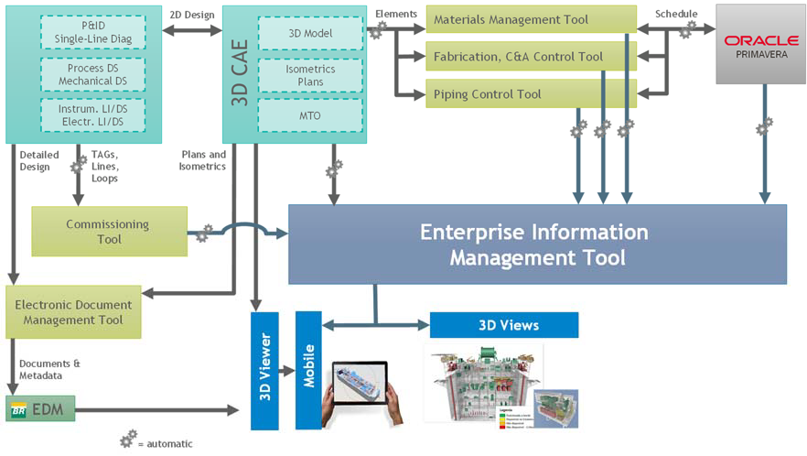
Schedule | Engineering | Control and Management | Integration | Deliverables | BUYER Software

Figure 1 – Computational Tools

  - Software tools are classified into five types:
    - Schedule: SELLER shall use the software specified in this Exhibit.
    - Engineering: SELLER shall choose one software tool that attend the specification in this Exhibit.
    - Control and Management: SELLER may use the software of its choice as long as it provides all the information.
    - Integration: SELLER may implement software capable of managing the information described in the Exhibit.
    - BUYER Software: BUYER will be responsible for these software tools and SELLER shall provide the properly formatted information that will be transferred to these systems.
SELLER shall issue its own system architecture with a flowchart of software tools relationships and requirements descriptions for each tool (similar to Figure 1). Additionally, the system architecture shall contain a Data Correlation Matrix, which includes, for the Enterprise Information Management Tool, all its data semantic and its correlated data in other software tools that holds relationship. The data Correlation Matrix shall include, at least, but not limited to, all minimum data described in Appendices of this Exhibit.

- SCHEDULE
  - SELLER shall use Primavera P6 (16.2 or higher version) software to elaborate and follow project schedule.
  - Planning software and control and management tools shall be part of an integrated process to enable the issuance of task sheets to the field and ensure the daily update of progress information received from the field.
  - Read-only access for Primavera P6 database shall be given to BUYER representatives. The access given should be compatible to security restrictions and technology solutions from BUYER computers standard software configuration.
  - SELLER shall provide to BUYER one (1) Primavera P6 license for each engineering site, hull, modules and two (2) Primavera P6 license for integration site. The license must allow the possibility to edit the projects.

- ENGINEERING
  - The CAE 2D application to be used for engineering design shall be according to I-ET-3000.00-1350-940-P4X-014 – Technical Requirements for Digital Engineering for BOT.
  - The CAE 3D application to be used for engineering design shall be according to I-ET-3000.00-1350-940-P4X-014 – Technical Requirements for Digital Engineering for BOT.

- CONTROL AND MANAGEMENT TOOLS
  - Supply chain management tool
    - Supply chain management tool shall be able to code, publish, retrieve and control all materials supplied, such as tagged items, bulk material and spare parts.
    - Materials description and identification codes may be loaded from CAE application catalogs to avoid typing errors.
    - The storage and traceability system shall provide visibility of the item/material actual location during storage and shall be updated with each new material input and every time a material is drawn from storage.
  - Manufacturing, construction and assembly control tools and piping control tool
    - Manufacturing, construction and assembly activities, whether execution or quality control, shall be controlled by computerized management systems. These systems shall control at least the following activity categories: piping, structure, equipment, electrical, instrumentation and automation, HVAC, and telecom.
    - Manufacturing, construction and assembly control tools shall be able to:
      - Perform scheduling of the activities for each activity category in accordance with the Project Schedule;
      - Control the supply of all inputs necessary for manufacturing, construction and assembly activities for each activity category;
      - Record and control all execution or quality control activities and all steps applicable to the different activity categories, including sequence of construction tasks;
      - Trace all equipment and all inspection and quality control activities in accordance with the EXHIBIT VII – Directives for Quality Assurance System;
      - Trace all execution activities in accordance with the contractual requirement;
      - Issue reports for all execution and inspection activities. These reports shall contain all information applicable to these activities. It follows the minimum information that the report shall contain:
- Identification of the item and activity;
- Date of the activity;
- Reference documents;
- Applicable acceptance criteria;
- Results obtained;
- Conclusive report;
- Signature of the professionals responsible for the activity.

    - Access to systems, both for foreman and quality inspectors, shall be controlled through a combining of username and electronic password that ensures the integrity of information and allows securely track of the author who made the update and quality reports generated.
    - The SELLER shall, whenever required, audit the information in the control systems to prevent any failures. BUYER at its sole discretion may also request access to the system to audit the information.
  - Commissioning activities management
    - The SELLER shall utilize software for the control and management of commissioning activities, according to EXHIBIT VIII – Directives for Commissioning Process. This software shall include a database capable of generating management reports and controlling commissionable items. Its purpose is to ensure immediate verification of the commissioning status of the UNIT's operating systems and maintain traceability of commissioning activities.
  - SELLER Electronic Document Management (EDM)
    - SELLER shall use a software to manage the engineering documentation and these documents shall also be uploaded to BUYER EDM.

- BUYER SYSTEMS
  - BUYER will be responsible for providing, support and training SELLER staff in Software tools listed below for SELLER use during the contract.
  - In case of discontinuation of any BUYER software listed in this section, BUYER will provide a replacing system with similar features and workflows. All requirements indicated will remain valid for the replacing system and shall be complied by SELLER. Database migration to replacing system, if applicable, will be carried out by BUYER.
  - In the case of SELLER share its construction scope with other companies, the SELLER shall guarantee the training of all subcontracted employees, through its own multipliers.
  - Software for financial measurement management
    - SELLER shall fill in an integrated Database, which will basically store data defining the payment milestones and data proving their accomplishment.
  - BUYER Electronic Document Management (EDM)
    - SELLER shall send to BUYER’s EDM all engineering documents issued according to EXHIBIT III – Directives for Product Development. The processes of documentation comment, review and approval by BUYER will be carried out in this tool.
  - Occurrence Report (RO)
    - Software tool which aims to comprise a set of information relative to the contract progress which reports all executed activities and shall be accorded by SELLER and BUYER. It will be possible to register service orders, non-conformity notes and all occurrences related to the contract execution, issued weekly, and signed by representatives of BUYER and SELLER.
    - The SELLER shall record the RO information on a daily basis, including front and occurrence information in the field.

- DELIVERABLES
  - SELLER shall periodically provide all information described in the Appendices of this Exhibit and 3D model visualization files.
  - SELLER shall comply with this EXHIBIT by providing to BUYER access to its databases through the use of a username and electronic password, or by reports issuance directly from its systems, which shall be provided in digital format. Alternatively, SELLER may fulfill its obligations by completing the appendices 1 to 24. BUYER may, at its sole discretion, align with SELLER regarding the information that shall be provided in the appendices, according to the project phase.
    - BUYER may, at its sole discretion, revise to reduce the information required in appendices 1 to 24, according to its necessity.
  - Frequency and format of deliveries shall be in accordance with Table 1:

Deliverables | Reference | Frequency | Format
Execution procedure for enterprise information management tool | According to item 11 of this Exhibit | Issue within 60 days from contract signature | Adobe (.pdf)
Manufacturing, construction and assembly information | Appendix 01 to 09 of that Exhibit | Daily | Excel (.xml) or input direct in BUYER database
Acquisition information | Appendix 10 of that Exhibit | According to Exhibits | Excel (.xml) or input direct in BUYER database
Planning information | Appendix 11 to 21 of that Exhibit | According to Exhibits | Excel (.xml) or input direct in BUYER database
Schedule | According to Exhibit VI – Directives for Planning and Control |  | *.xer  (Primavera P6 16.2 or higher version)
3D Viewer | I-ET-3000.00-1350-940-P4X-014 – Technical Requirements for Digital Engineering for BOT
3D viewer mobile
3D view | Status according to the standardized colors in Appendix  24 | Weekly (1st working day of the week) | Navisworks (.nwd)
Table 1 - Deliverables

  - The 3D model visualization file can be delivered with status information in a single file or in separate files by status type (Pipe, Structure, Electrical, Supply Status, etc.).

- APPENDICES
  - The following appendices are part of this Exhibit:
- Appendix 01 – Piping Control – Spool
- Appendix 02 – Piping Control – Joint
- Appendix 03 – Piping Support Control
- Appendix 04 – Valves Control
- Appendix 05 – Structure Control
- Appendix 06 – Structure Control - Joint
- Appendix 07 – Equipment Control
- Appendix 08 – Electrical, Instrumentation and Telecom Control
- Appendix 09 – Coating Control
- Appendix 10 – Procurement Control
- Appendix 11 – Engineering Control
- Appendix 12 – Rundown Curves
- Appendix 13 – Physical S Curve
- Appendix 14 – Financial S Curve
- Appendix 15 – Resource Histogram
- Appendix 16 – Executive Summary
- Appendix 17 – Weekly Programming
- Appendix 18 – Weekly Programming – for item
- Appendix 19 – Milestones Control
- Appendix 20 – Risks
- Appendix 21 – Action Plan
- Appendix 22 – KPI
- Appendix 23 – Safety Studies
- Appendix 24 – Standardized Color for 3D model

